[Southerly Journal 78.1, 2018]

The Sheep That I Am
By Orpheus (Pumpkin) Merino
[Transcribed into human language by Teya Brooks Pribac]

‘What is a vegan?’ I asked mum. She told us that that kind lady, Michelle, who always brings nice bread when she visits, is putting together a festschrift (another word we didn’t understand but it turned out to be far less complicated than the first one) for dad. Since mum often reads to us before putting us to bed with our evening snacks we thought it would be fun, when the issue is out, to hear what other human people say about, or write for, dad. I call them mum and dad because they are the only real mum and dad I’ve ever known.
I was born near Camden, NSW, in what I later learnt was a concentration camp for my people. My biological mum had died suddenly and I was found lying beside her unresponsive but still warm body when I was only a few days old. A nice doctor, Sy, happened to be around at the time and she told the managers that she knew of some kind folks who would be willing to take me in. So after the logistics had been sorted out – this took a little while and it included a trip to a tiny place in Redfern for two nights – I was brought to my new permanent home in the mountains – to, well, mum and dad.
This is me at about two weeks of age, on 19 October 2013, watching the big boys from dad’s writing room.

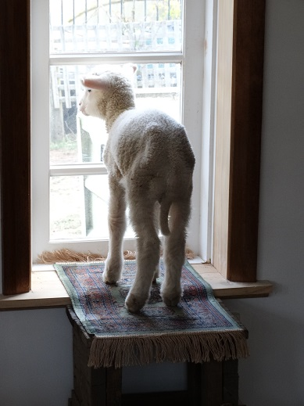

The big boys, yeah, there was – still is, though not so big anymore – them too. Henry and Jonathan. They looked giant!

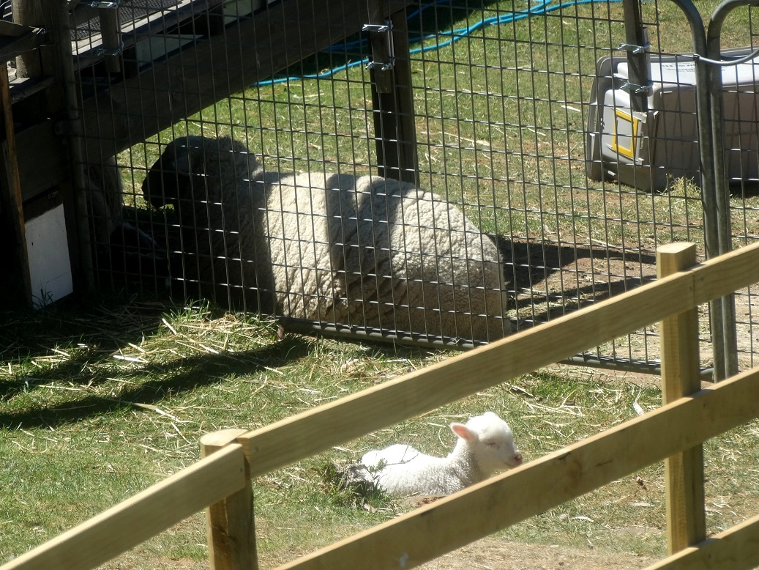

But also kinda cute, especially when sleeping

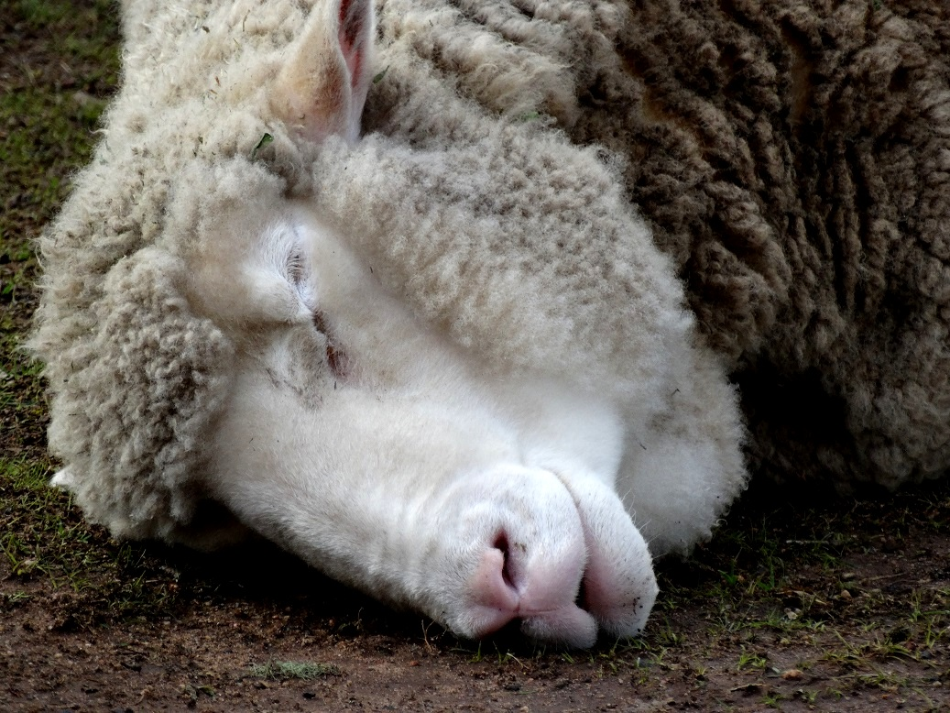

I couldn’t take my eyes off them.
Family!!!!
I ran towards them bursting with joy. But gosh was I lucky there was a fence between us, as I soon realised. They would have butted me to the other side of the world judging by the way they initially attacked that life-saving barrier. Particularly Jonny. He’s always been a bit of a wuss, serious attachment issues IMHO, doesn’t know how to relate but really wants to, so he gets frustrated... He never talks about his past so not sure where it all comes from. He’s also the only one among the four of us – yes, there’s a fourth trouble, Jason – without a scrotum. This tends to suggest that it was purposefully removed by humans. And humans don’t do this nicely.

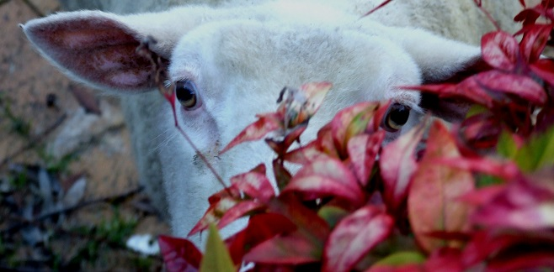

There are some stories about humans literally biting off lambs’ balls as some kind of twisted virility show or something, but the more common, though also very painful, way of doing this is to put a tight rubber band around the testicles to cut the blood supply and let them drop off. Without pain relief of course because that would be too expensive in a for-profit setting. So not sure what Jonny went through but it’s well known that both physical pain and psychological distress can have not only life-long consequences but can even transfer across generations!
Jonny got better over the years. I guess we’ve all – the sheep and the humans – played our own parts in it. He still gets the fits, like, when it’s windy or rainy or something that doesn’t suit him, he annoys the shit out of everyone, but it doesn’t really happen all that often these days, and we ourselves have learnt a few tricks: for example, we discovered that trying to calm him down or ignoring his anxiety entirely instead of absorbing it and spreading it all over the place, as it can happen in shared spaces, benefits us all.
Anyway, mum and dad wisely decided that it wasn’t safe for me to go around unsupervised. At the same time they were determined not to turn me into a ‘pet’ (and I can understand why if I just look at Jason who was obviously raised as a ‘pet’). But things could get a bit challenging in this ‘pet’-avoidance business, like that time, a few weeks after my Redfern adventure, when equipped with a dog harness (!) I ended up back in Sydney, at the Forum Restaurant in Darlington this time. As a guest, that is; of honour, if I may add. Mum and dad co-organised the Not The Melbourne Cup (an alternative event to the national craze for horse abuse) and since they couldn’t leave me alone with the big boys they took me with them. That’s me with dad there:

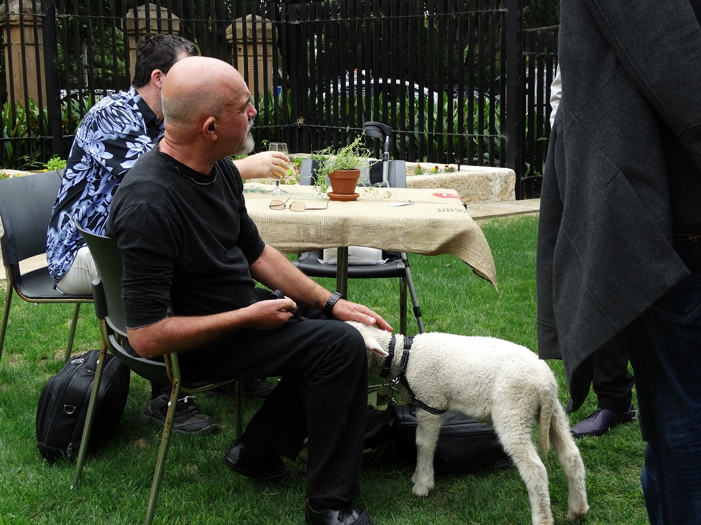

Of course at the time I didn’t realise how lucky I was to be granted the privilege of staying under the restaurant table nibbling at the fresh grass instead of marinating on a plate on top of it. Nor did it make much sense to me when the cook, upon hearing about my presence, came over and sobbed her guts out, so to speak. Soaked to the bone, I enjoyed it anyway since, between one drop and another, she took time to caress me gently, and all babies need love.
Back at home, and back to challenges, the resolution made sense: the baby (me) needs love, but also needs the opportunity to be(come) a ‘real sheep’ (or as close as one could get in our particular situation). The big boys could teach me the latter but of course they couldn’t feed me nor could they be trusted to let me live past the first fence-free encounter, let alone provide something that would even remotely resemble the ‘safe base’ all infants need. So mimicking a more normative sheep developmental context, the humans moved to the paddock for most of the day (I slept in the house with them at night until I was big enough to be no easy target for predators), acting the way a ewe mum would (or the way they imagined she would), basically making me feel safe as I was exploring the socio-natural environment and responding to me every time I said something (lambs talk a lot! We are constantly checking that mum is around and paying attention), negotiating relations with the big boys while they in turn were going about their usual sheep business and I followed their every move (albeit at some distance).
At some point I decided I was big enough (and that the big boys were kind enough) so while the humans were distracted with the dog I sneaked through the fence where the big boys were. I began grazing very close to the fence (ready to escape in an emergency), a few metres away from them. They seemed fine with that so I approached a bit more. And a bit more. And a bit more. Very slowly, and in stages, I climbed up the little hill where Henry was grazing. I was so close to him, it felt super cool.
Then suddenly he turns around, spreads his shoulders, lowers his head, ears up. You’re a dead lamb.

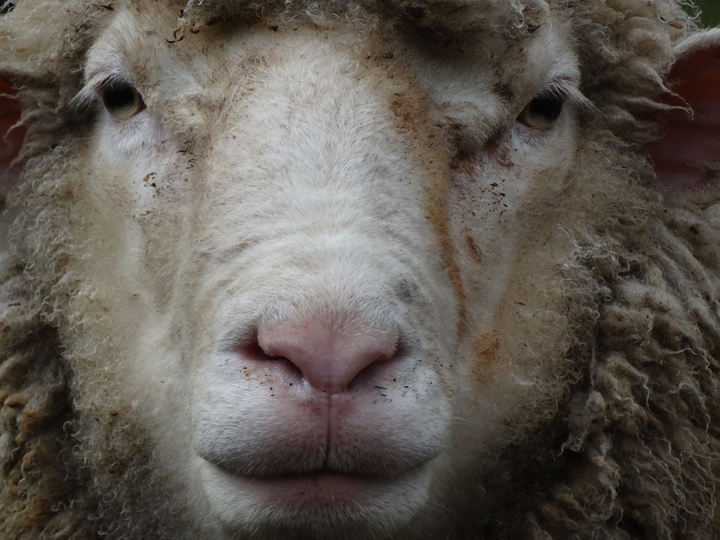

‘OMG!!!! No, no, no, this is not happening! What do I do???’ Maybe I should have called mum but I didn’t. I thought (not that there was much time to think….): ‘Okay, if I want him to accept me (and I did!) I’ve got to show guts, right?! No-one’s gonna respect a sissy, right?!’ So I did what he did: spread shoulders, pricked ears, lowered head…. problem was that the only thing I could see then was his feet, and up to his knees. ‘Should I go for the knee? Kick real hard, and run!’ But, oh phew!!, that’s when mum turned up, almost as upset as I was. She yelled. Henry got distracted. And I ran! Soooooo fast!
‘Were you really going to kill me that day?’ I asked Henry months later.
‘No kiddo. You just needed to know who’s boss. Also, I guess I was a bit jealous. You turn up one day, we have no say in it, you get all the attention, you know… stuff.’
One of the many problems with captivity (and probably a minor one) is that it infantilises you regardless how hard the humans may try to avoid it. I mean, it’s not normal for an adult sheep to want to hang out with mum and dad and be jealous if you get less attention from them than someone else.
By the way, I’m a big man too now. The biggest actually, and the only one with horns and an intact tail so they respect me. First I thought it’s because they know I could hurt them with the horns if I wanted to, but then I realised there’s more to it. For instance, they don’t go anywhere without me. Sometimes the three of them will be standing at the bottom of the main paddock obviously really wanting to go to that nice grass on the other side of the bridge but they don’t until I come, whereas they are happy to go if someone else is missing – like Jason when he gets obsessed with some door around the place that he’s determined to open and he’s not paying attention to anything else. (Ah, Jason. He was found at a brickyard with rotten feet. He was supposed to stay here only temporarily while mum was treating his feet but then dad said, ‘what’s a flock without a black sheep,’ so he stayed. I don’t think he’d ever met other sheep before. Raised by a human, then dumped. Poor bugger. He doesn’t talk about it, not sure if he doesn’t want to or has truly repressed the experience when he says he can’t remember. He’s quite cute, and he knows it so I tend not to remind him too often.)

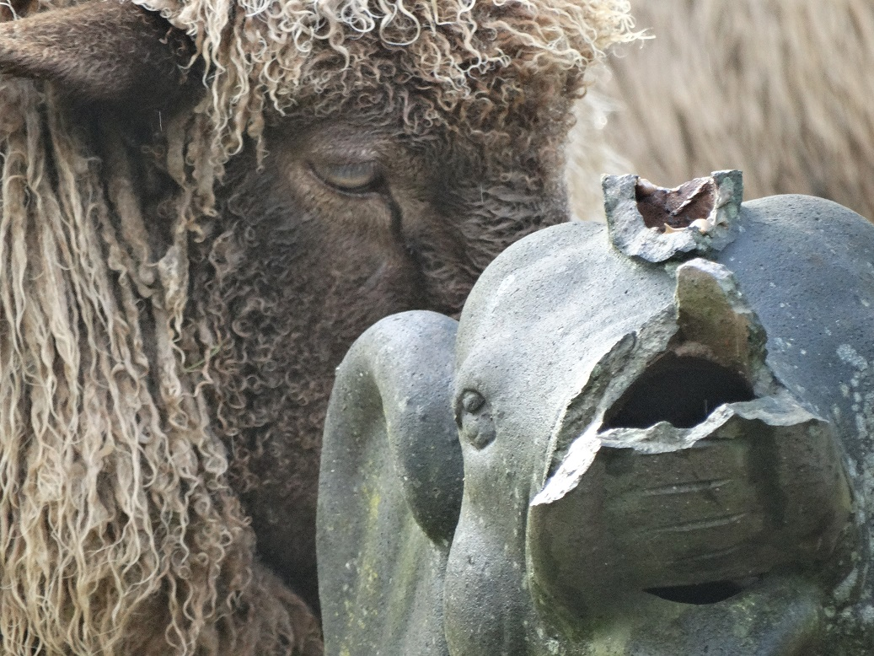

So I think they see me as a kind of leader, not in a bossy kind of way (at least most of the time) but it’s more like as if they trusted me, felt somehow safer when I’m around. I don’t really know why, but it makes me feel good. Of course I still like visiting dad’s writing room: look through my old window, nibble at the paper, check the progress on The Grass Library – the book dad’s writing about this place and us – etc.

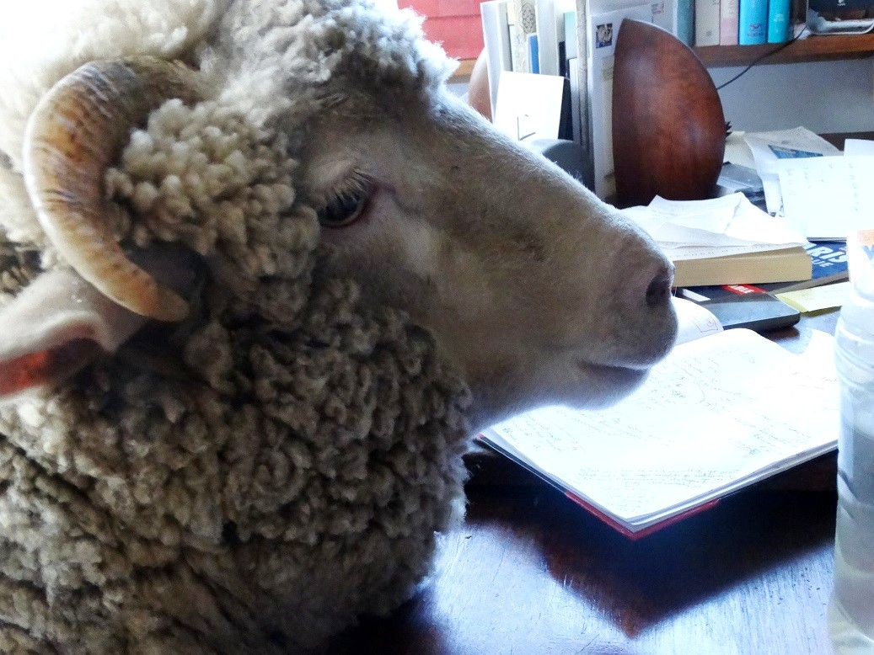

Anyway, in the overall life’s pretty good here, especially compared to what we’ve heard other sheep and many other animals endure. A whole new story.
It all started (well, for us at least) one day when mum announced that she’d found another book on sheep. We’d already learnt some fascinating stuff from the previous sheep book, including the fact that homosexuality is really a thing among male sheep even when ewes are around. That made her feel better about our situation since she and dad had often wondered whether we may be missing girls. She was really looking forward to reading this one to us, too – and we, of course, to hear it. Imagine the surprise then – disappointment actually – when she read most of it in silence. Okay, we heard about natural wormers and all the little boxes of yummy minerals we’re supposed to have in our room and hopefully one day we will! But what about the rest of the book?? She was reluctant to respond when questioned, then said that the book was not so much about sheep as it was about humans, in fact, humans’ use of sheep.
‘Use? What do you mean by use?’
Dad joined in, and Charlie, the dog, who apparently had heard it all before, settled in the long grass near the lemon tree, for what was going to be a long – and bloody difficult! – educational session about the world outside our little cosy bubble of ignorance and bliss. I still wonder whether we needed to learn about all that.
‘Do you remember when we first met Lily?’
I didn’t – I hadn’t yet been born at the time – but Henry and Jonny told us the story. A few weeks after H and J arrived here, which was about a month after mum and dad had moved in, they saw a human family walking past with a sheep on a leash, the way humans tend to walk around with dogs. Mum and dad got really excited (like-minded humans in the area???) and invited them in. Then mum saw blood on Lily’s rear and inquired. The female human explained that Lily had just had a baby. A baby! Followed, naturally, by the question: Where is the baby? The baby, as it turns out, was locked away to be disposed of at a later time. The pact – the one between humans and other animals – allows humans to do this, or so the story goes: we give Lily oats, she gives us milk. The baby – an inconvenience, he could drink up the milk that Mother Nature designed for him and that his biological mum would certainly want him to have. So the friends-not-to-be were quickly rushed off our property with an invitation to never come back.
Okay, super twisted, poor Lily and her baby, but I’ve heard the story before. What followed, however, was news to us all.
As it turns out, the act by the humans from the story above was not some kind of sick aberration; removing babies from mothers so humans can steal their milk is standard practice in what they call ‘animal agriculture.’

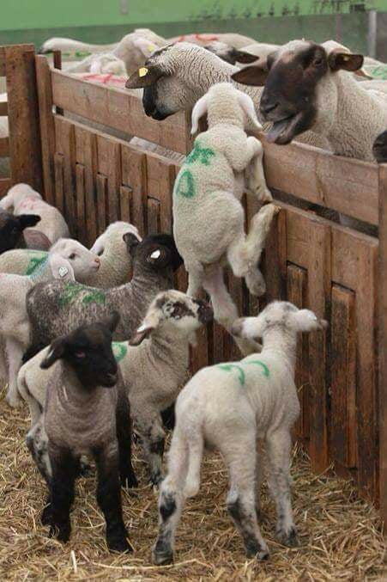

Cows are most affected by it because that’s the milk humans consume most, but the practice extends to other species too, including sheep and goats. The female babies are normally kept for further milk exploitation while the boys are killed for their flesh, skin and other things. Wow!
The same with hens used for eggs. The females are kept, the boys, on the other hand, who clearly can’t lay eggs, are usually ground up alive as tiny chicks. Plus the hens are often confined to cages so they can’t even spread their wings properly, and the ones in so-called ‘free-ranging’ facilities don’t fare much better either.
Then there are the ‘meat animals’ – animals bred specifically for their flesh to be turned into consumable goods for humans. The bodies of pigs and hens have been so mutilated over the past century of selective breeding that today they carry far more flesh than their bones and internal organs can handle! The size of a ‘meat chicken’ has quadrupled over the past 60 years! Humans of course don’t do these things ‘holistically’, they just change and take whatever they need – Takers as aptly described by Daniel Quinn.
And in the end, whether they survive the farm or not, everyone, and I mean quite literally everyone, sooner or later ends up having their throats slit, most of them at the slaughterhouse – a place designated to kill us.
There is no pact between human and nonhuman animals. We’ve never signed up for this.
And they went on, mum and dad, stories about other species and other captive and non-captive settings: circuses, zoos, laboratories, puppy farms, persecution of so-called ‘pest species’ dying a slow and painful death from poisons etc., and many others – all others.
Merinos, too. Enslaved for our wool, a huge chunk of our skin around the bum cut off when we are tiny babies, tail docking, castration, shearing every year – there’s some awful shearers out there too who punch and kick! – little or no shelter, little or no food and water a lot of the time – sheep can live on air anyway, right? And then when our ‘function’ is deemed performed, if we’re still breathing, at the age of 5 or 6 – my age – when the quality of our wool supposedly deteriorates, off to the S word.
Wow… The whole world suddenly felt like a huge torture chamber, a nightmare I wanted to wake up from and never think of again.

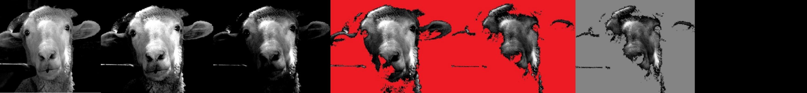

I had to ask:
‘Do you guys partake in this?’
‘No! Well, at least we try not to. Sometimes it’s unavoidable: there are hidden animal products everywhere. But we avoid the avoidable and support businesses and initiatives that are clear about what goes into the products and how they are produced, which classifies us as vegan.’
Phew, what a relief, but: ‘So what is a vegan?’
‘It’s an extremist position whereby one does everything one can to avoid participating (directly or indirectly) in violence, and that includes avoiding killing or paying others to kill other animals so I can eat them even though I don’t need to.’
‘Why is this extremist?’
‘Because lions eat zebras.’
‘What?’
‘Lions eat zebras.’
‘Yes, okay, that’s not nice for the zebra but what’s this got to do with what humans do to my people and others that you talked about before?’
‘Not much. It just makes humans feel better about eating other animals knowing that lions kill zebra, and that’s a recurrent excuse when trying to defend their food and other choices.’
The other thing that seems to help, as I learnt, is the old myth of nature being ‘red in tooth and claw’ – a relic, apparently, from the human patriarchal past – ‘don’t let me start on that,’ mum said so I didn’t push, I just had to promise to keep in mind that human males too were victims of their society that imposed unrealistic expectations on them so I shouldn’t judge them too harshly (I found myself wondering whether dad was affected too by this but didn’t feel I could ask, just figured that his feminine brutality or whatever John called it may have spared him some of the trouble, I certainly hope so). The idea of nonhuman animals being out there all alone and the only thing they do is fight and rape is apparently still sticking with most humans and this myth must help them do what they do to us. No love – no problem.

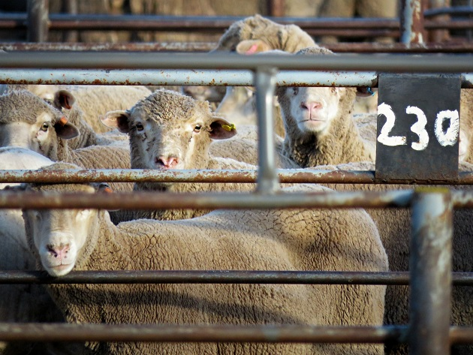

‘Okay, how about this: those humans who really want to eat flesh (which I understand is most of you but this may reduce the numbers of devotees) go out and kill free-living animals themselves and then eat them?’
Not that I’d want to be killed when walking through the bush and I don’t really want Amanda, the rabbit who comes to say hello every morning, dead, or even Juicy, the fox – we call her Juicy because she looks like a solid form of the orange juice humans drink in the morning – anyway, she can get a bit nasty with some other animals and she certainly scared the shit out of us when we first met her but then we felt sorry for her when the magpies attacked her and she was hiding as best as she could under that lavender bush near the fence – she was really just a baby…Anyway, I like her too, just thinking that letting animals enjoy their freedom and then killing them when hungry like the lion&zebra story would be a bit more of a fair game?
A popular ‘solution’ proposal, I’m told, by those reluctant to give up animal flesh, but far from devoid of practical problems. Aside from the fact that there’s no nice way of killing someone who doesn’t want to die and with every death there’s usually someone left behind in grief, with the human population currently approaching 8 billion, following this practice combined with their appetite for flesh humans would probably wipe out wild animals within a day or two. In fact, only about 5% of all mammals on the planet are wild! The rest are humans (36%) and us, so-called farm animals (59%). As for those with a taste for birds, only 30% of all birds on the planet are wild birds!
Freaky figures, ay?

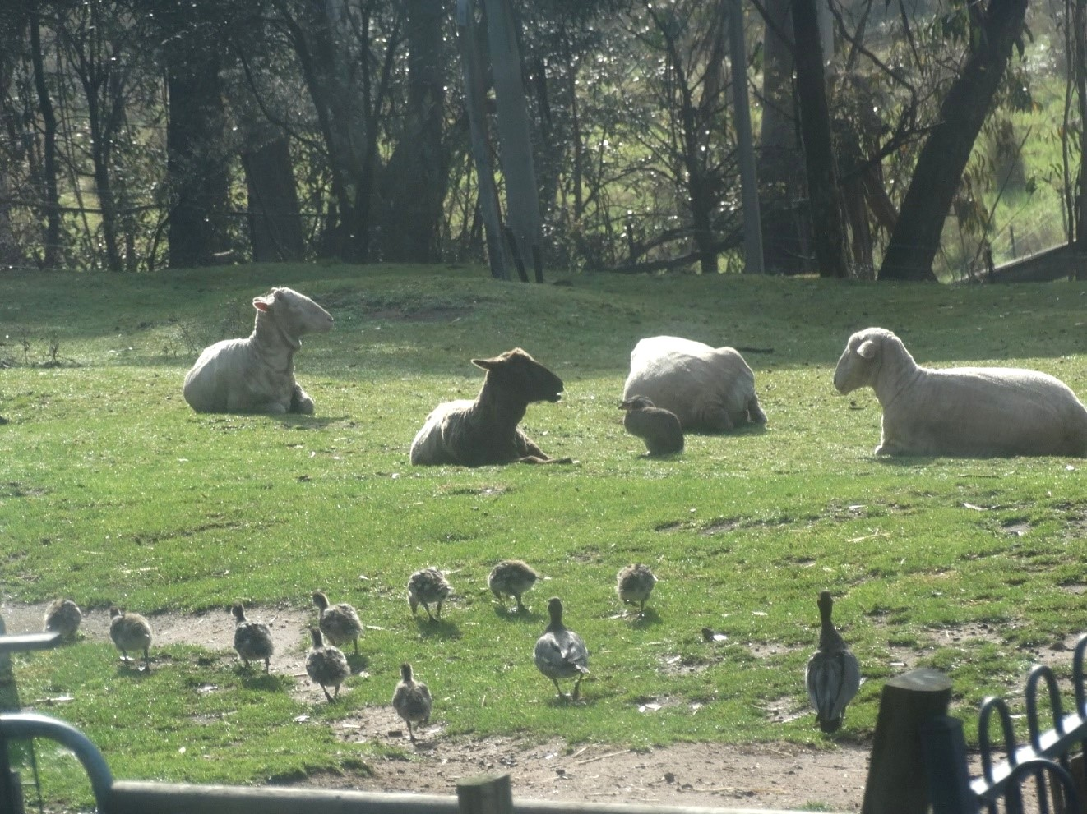

Humans are a seriously messed up species. Broken?
They’d come up with any excuse to stay in their comfort zone.
Another common excuse humans apparently use to justify what they do to us is that there is a lot of human suffering in the world and that humans should focus on eradicating that before thinking of other animals (as if these two things were somehow mutually exclusive). It’s true, apparently, that there’s a lot of human suffering, too. There’s the sweatshops, for example, nasty places where they enslave humans, including children, to mass produce clothes, shoes and other stuff for other humans. With all the self-proclaimed humanitarians around, mum says, one would expect fair-trade to be booming, an easy thing consumers have a direct say in.
‘Is it booming?’
‘Nope. Of course not.’
And then there’s the slaughterhouse workers, another victim of other humans’ ethical numbness.
‘Slaughterhouse workers? You mean those humans that kill animals like me for a living?’
‘Yes, those ones.’
‘But they are horrible humans, the worst of the worst!!’
But even that turns out to be more complicated than I first realised. For human animals to be able to eat nonhuman animals someone has to kill them. For human animals to be able to eat many nonhuman animals someone has to kill many of them. This eventually affects the killers, their families, their entire communities. Apparently they have higher crime rates, domestic violence and all sorts of nasty things. The sights, the sounds, the smells, spared most humans, penetrate clothes, skin, psyche. An ex slaughterman once explained in his blog:
Out of desperation you send your mind elsewhere so that you don’t end up like those guys who lose it. Like the guy who fell on his knees praying to God for forgiveness. Or the guy they hauled off to the mental hospital that kept having nightmares that chickens were after him. I’ve had those, too. Very creepy.
People tend to avoid you, even others at the plant, whether from instinct or because they know what you do and can’t understand how you can do it night after night. (…) You feel isolated from society, not a part of it. Alone. You know you’re different from most people. (…) They have not seen what you have seen. And they don’t want to. They don’t even want to hear about it.

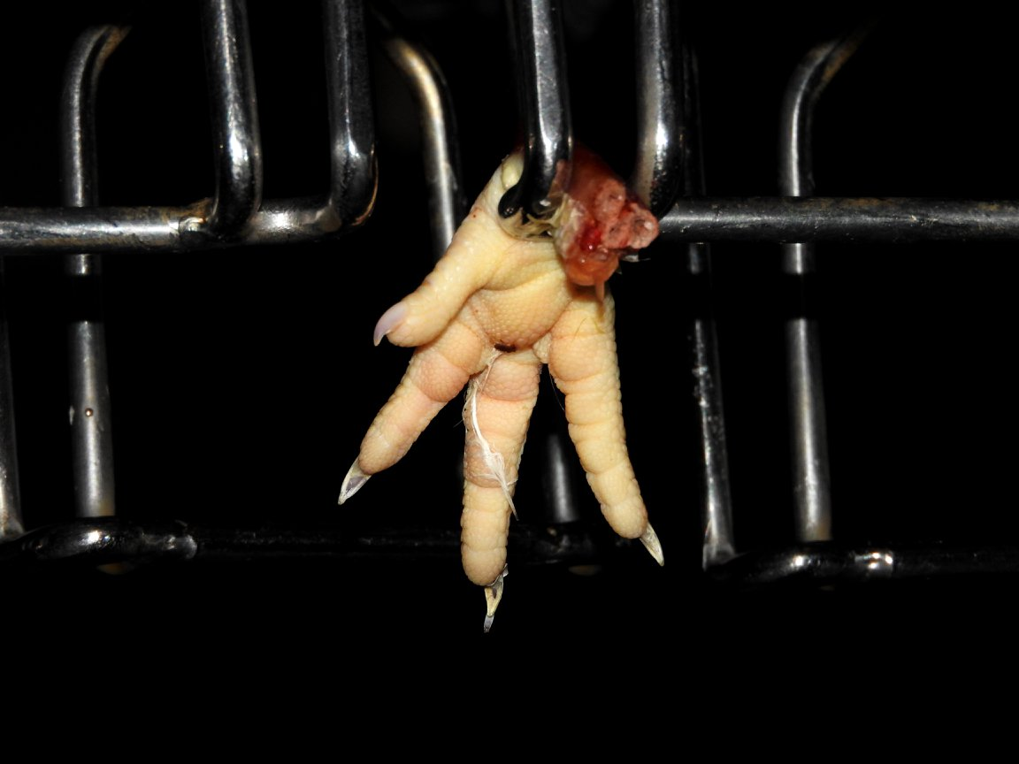

‘Sad but true, my beloved darlings, most humans who consume these products in one form or another don’t really want to know what goes on in these places….’
They’ve given up their right to not be a perpetrator, as someone put it. Presented with the opportunity, they’ve grasped, and don’t want to let go of, the privilege of not knowing (even when they do know).
They may feel powerless to change the system. Even when they recognise it as unjust they may choose not to act. ‘What difference will it make if I change my way, most others won’t and the situation will remain the same?’
But will it?
And in the end, doesn’t it all narrow down to personal choice? Am I okay with what I’m supporting? Yes – No. Simple. Some would say Yes, most would probably opt for the No. Besides, choosing not to change what is in one’s capacity to change is already making a difference and it will continue to do so – for the worse.
‘There’s some hope though!’
‘Hope?’ Have mum and dad gone totally nuts?! ‘Seriously? This whole thing really does not sound good to me…’
But apparently humans are becoming more sensitive to other animals’ suffering, more aware of our shared capacities more generally. Veganism seems to be on the rise – Tolstoy said that 130 years ago (!) and we’re worse off than we were then but okay, we’ve got to stay positive, right?
What if it’s for real this time?
Encouraged perhaps also by the environmental devastation induced by current human practices? Another taboo that’s about to pop the lid of its storage jar.
Perhaps they just need to reach a critical mass. The rest may be easy.
After all humans are followers.

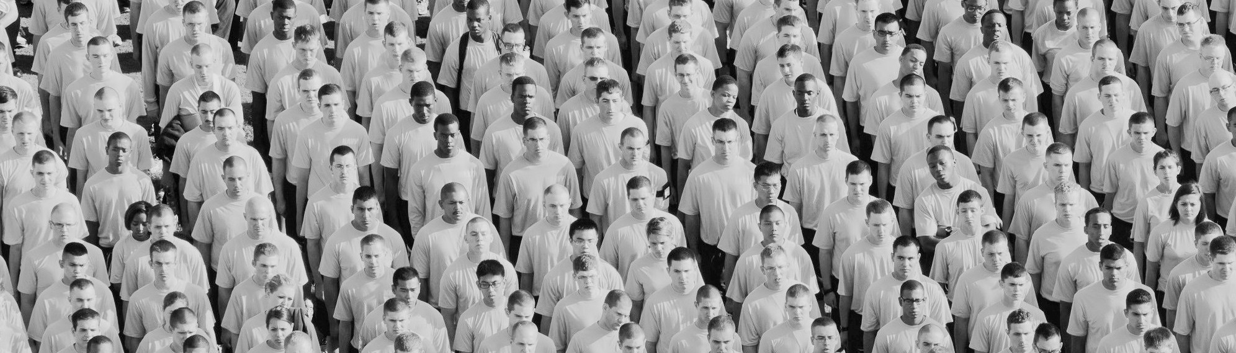

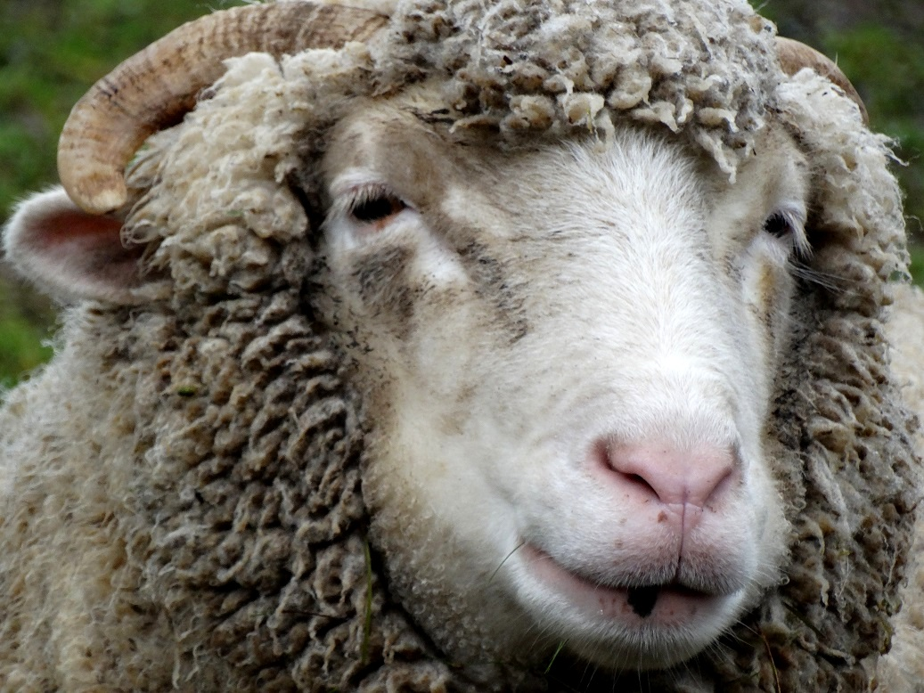

_______________________________________________

Photo credits/sources:
Hen’s foot: Animal Activism Victoria; Sheep at the sales yards: ©Veronica Rios, The Forgotten Photography; Lambs and mums: animal activism archives; Human crowd: Pexels; Photos of Pumpkin in the writing room: David Brooks; Other photos: TBP.
Referenced works:
Animals Australia on Sheep
Armstrong, P. Sheep. London: Reaktion Books Ltd, 2016.
Boyer, K., G. Scotton and K. Wayne. ‘Beyond complicity and denial: Nonhuman animal advocacy and the right to live justly.’ Intervention or Protest: Acting for Nonhuman Animals, edited by G. Garmendia da Trindade and A. Woodhall. Wilmington: Vernon Press 2016, 159-182.
Brooks Pribac, T. ‘Someone not Something: Dismantling the Prejudicial Barrier in Knowing Animals (and the Grief which Follows). Animal Studies Journal, 5(2), 2016, 52-77, http://ro.uow.edu.au/asj/vol5/iss2/4
Butler, V. ‘Inside the mind of a killer.’ The Cyberactivist, 31 August 2003.
Clark, C. et al. ‘Long-term and Trans-generational Effects of Neonatal Experience on Sheep Behaviour.’ Biology Letters 10(7), 2014, doi 10.1098/rsbl.2014.0273.
Coleby, P. Natural Sheep Care. Austin (TX): Acres U.S.A., 2012 [2006].
Cowspiracy – documentary on the environmental impact of animal agriculture
Dagg, A.I. Animal Friendships. Cambridge: Cambridge University Press, 2011.
Dillard, J. ‘Slaughterhouse nightmare: Psychological harm suffered by slaughterhouse employees and the possibility of redress through legal reform.’ Georgetown Journal on Poverty Law and Policy, 15(2), 2008, 391-408, https://papers.ssrn.com/sol3/papers.cfm?abstract_id=1016401
Dominion – Australian documentary on animal agriculture
Fitzgerald, A.J. ‘A social history of the slaughterhouse: From inception to contemporary implications.’ Human Ecology Review, 17(1), 2010, 58-69, http://w.humanecologyreview.org/pastissues/her171/Fitzgerald.pdf
Fitzgerald, A.J., L. Kalof and T. Dietz. ‘Spillover from “The Jungle” into the larger community: Slaughterhouses and increased crime rates.’ Organization and Environment, 22(2), 2009, 158-184.
PeTA’s shearing investigation
Quinn, D. Ishmael: An Adventure of the Mind and Spirit. New York: Bantam Books, 1992.
Tolstoy, L. ‘Introduction - the first step.’ Howard Williams, The Ethics of Diet: an Anthology of Vegetarian Thought, abridged version. Guildford: White Crows Books, 2009, http://www.ivu.org/history/williams/
Zuidhof, M. et al. ‘Growth, Efficiency, and Yield of Commercial Broilers from 1957, 1978, and 2005.’ Poultry Science, 93(12), 2014, 2970-2982.

